Open Call for Challenge Owner
Guide for Applicants

Table of Contents
1. Introduction 3
Expected Project Outcomes 3
About the Consortium 3
2. Why SoTECIN Factory CALL for challenges? 4
3. eligibility critera 7
4. how to apply? 8
5. How will we evaluate Challenges? 9
6. What are the tasks of a challenge owner? 9
7. obligation of Challenge Owners 10
8. intellectual property rights 10

Introduction
Horizon Europe project SoTecIn Factory – Social and Technological Innovation Factory for Low-Carbon and Circular Industrial Value Chains – aims to connect industry with society in a community of mission-oriented social innovators, to support social entrepreneurs in their drive to increase the circularity of key product value chains, and to promote a culture of social innovation in European manufacturing businesses.
SoTecIn Factory is focused on the 4 out of 7 Key Product Value Chains (Textiles, Plastics & Packaging, and Food, Water & Nutrients), as defined by EU Circular Economy Action Plan.
It supports systemic transformation towards restructuring value chains to be low-carbon and circular, by implementing higher value circular economy strategies, i.e. reuse, repair, refurbish and remanufacture.

Expected Project Outcomes
- Strengthened resilience and sustainability of the 7 European key value chains.
- Innovations that combine technological and social innovation and support industry in their transition and the achievement of EU’s priorities
- Inclusive entrepreneurship with a positive social impact
- A new generation of technologically savvy social entrepreneurs
- New business models capitalising on new partnerships between industry and society
- Support for 50 mission-oriented social entrepreneurs with services regarding governance (through the creation of stewardship councils for each innovation), business models, capacity-building, fund-raising and exploitation.
- 30 mission-oriented pre-market demonstration projects.
- Long-term impact for increased autonomy in key strategic value chains for a resilient industry.

About the Consortium
Led by Laboratório Instituto de Engenharia de Sistemas e Computadores, Tecnologia e Ciência (INESC TEC, Portugal), the project involves 6 European Partners from six countries, including research and innovation institutes as well as global community networks.

This document summarizes the main assumptions of the SoTecIn Factory Call for Challenges under the SoTecIn Factory project, that will be continuously open from February 27, 2023 at 13:00 (Brussels Time) and with a deadline on March 16, 2023 (18:00 CET).

Where can you find key information regarding this Open Call?
- SoTecIn Factory website for general information about the program,
- If you have any doubts related to the Open Call requirements or application form, please contact: oezkan@bwcon.de
- If you need support in describing your challenge, please contact oezkan@bwcon.de
- If you have any technical problem or doubt when filling in the online Application Form tell us directly in: oezkan@bwcon.de
- Application website, where you can find all documents: Open Calls - SoTecIn Factory

Why SoTECIN Factory CALL for challenges?
The objective of this SoTecIn Factory Call for Challenges is to identify real-life circular industry challenges in the conext of the regional Mission. Once the challenges are selected, they will be pulished on the Open Call for tech-savvy Innovators, to which these innovators can then apply with their solution approaches. 50 social innovations will be selected and funded with 15k EUR (25 per year 2023 and 25 per year 2024). After that there will be an implementation of 30 pre-market demonstrations (15 per year 2023 and 15 per year 24). It is expected that the Challenge Owners contribute to the co-development and co-design together with the tech-savvy innovators.
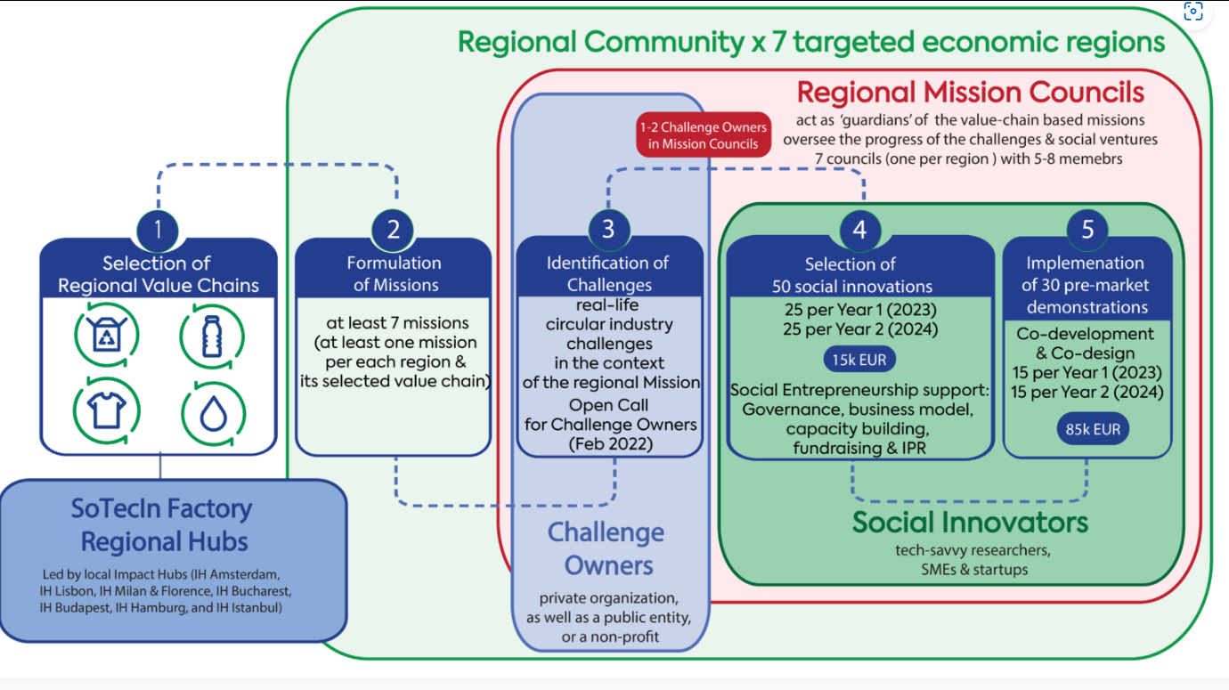
SoTecIn Factory’s activities span over 7 European economic regions. Each region encapsulates several countries, adding up to 31 states in total.
The following list represents the overview of 7 regions targeted by SoTecIn Factory.
- Netherlands (North-West, including Northern France, Belgium, Luxembourg, Ireland)
- Portugal (South-West, including Spain, Southern France);
- Italy (Centre-South, including Slovenia, Croatia, Malta);
- Romania (South-East, including Greece, Bulgaria, Cyprus, Serbia, Ukraine);
- Hungary (North-East, including Slovakia, Poland, Estonia, Lithuania, Latvia);
- Germany (Centre-North, including Denmark, Austria, Sweden, Finland).
- Turkey (East, including Armenia and Georgia)
Challenge Owners can apply to the missions, that have been formulated from the regional communities for each region:

Amsterdam:
"Leverage digitisation and data by connecting actors in the textile value chain in the EU to empower decision-making towards higher R circular economy by increasing transparency and traceability."

Bucharest:
"Foster closer collaboration between farmers, distributors, and retailers throughout the regional food value chain, and increase their capacity to leverage R&D, sustainable technologies and production methods, and circular strategies to help them become more resilient, in the move towards a regenerative, circular food value chain."

Budapest:
"Build more resilient regional food systems by improving farmers’ access to resources and fostering closer connections between farmers and consumers to reduce the distance between production and consumption, to facilitate production of quality food, and to inspire more sustainable localised consumption and production."

Hamburg:
"Leverage circular design, enabling technologies, and knowledge sharing to reduce and replace single use plastics and to maximise the potential of packaging solutions that close material loops, while enabling the main value chain actor across to adopt them by 2030."

Istanbul:
"Leverage digitalization, data centric approaches, biotech, and other solutions to increase the transparency and traceability of the agri-food value chain, reduce food waste, and radically reduce impacts stemming from meat and dairy production."
Lisbon:
"Support Iberian farmers, producers and consumers in a 3R agricultural revolution (one that is regional, regenerative, and resource-efficient) through platforms, tools, financial incentives, education, and transparent information."

Milan:
"1. Enable greater transparency, traceability and verifiability of product-level data and incentivise reduced production impacts by improving mechanisms for data collection, verification and sharing.
2. Develop new digital solutions, production technologies and services to drive circularity throughout the whole lifecycle of products, whilst encouraging greater collaboration across the value chain, and increasing awareness of consumers of the impacts of their clothing."

What is a Challenge?

For this contest, a Challenge is defined as a critical sustainability problem in the context of circular economy and its 7 R’s (Refuse, Rethink, Reduce, Reuse, Repair, Refurbish, Remanufacture). Tech-savvy Innovators need to be able to apply with a dedicated solution approach to the challenge by using social innovation and technologies.

What kind of Challenges are we looking for?

SoTecIn Factory Consortium is looking for Challenges that build on the formulated regional Missions and have the potential to bring a greater societal value as a solution.
We are looking for institutions and organisations that will propose a particular problem that would like to see solved. The consortium will provide support to help in the detailed definition of the Challenge.

Who is a Challenge Owner?

Challenge Owner is a party (private, public, non-profit - from an organization focused on national sustainability transition to a corporate deadline with a specific circular economy value chain challenge) which sets a specific regional, circular innovation challenge for the SoTecIn Factory program as they have an interest in it being solved through high-value circular solutions.

A Challenge Owner is a representative of an organization who knows the existing challenges of the organization and seeks to find a solution for it and at the same time has the task and responsibility to implement it.
The size of the organization is not significant, but the challenge the organization faces needs to fit the predefined missions in the region. In addition, a representative of the organization must be accessible and active in the further course of the project (namely, monitoring and supporting the implementation of the solution provided by the chosen sub-grantee).

How does the process look like for a Challenge Owner?

The Challenge Owner submits a challenge online. The Challenges will be reviewed for their eligibility (3. Eligibility criteria). Then, the steering committee of SoTecIn Factory, namely the Mission Councils, will review the submitted challenges and might ask for clarification/ adaptation of the formulated Challenges. The selected and finalized Challenges will then be published during the Open Call for tech-savvy Innovators for them to apply to them with their solutions. Challenge Owners co-select solutions that meet their direct needs and support the funded implementation.

What is the benefit for a Challenge Owner?
Challenge Owners get the chance to receive an innovative solution for their individual problem of their organization, that is funded by the European Commission. (The selected tech-savvy innovators will receive the funding to work on their solution and to implement it within the Challenge Owner’s business environment).
Challenge Owners can participate directly in the implementation of the solution approach and state their needs and requirements to the tech-savvy innovators.
Challenge Owners can strengthen their own network of core circular economy actors in the EU.
Challenge Owners will be able to gain first-hand insights into newest circular innovations and high-impact technologies.
Challenge Owners will be included on the SoTecIn Factory website as key contributors to the project, drawing attention to their organization and their activities.

eligibility critera
All Applicants will have to abide by all general requirements described in Sections from 3.1 to 3.6 of this Guide for Applicants in order to be considered eligible for the SoTecIn Factory Call for Challenges.
  - Type of beneficiaries
The call is addressed to the following type of applicants:
- Challenge Owner is a private, public, non-profit party
- Challenge Owner is an incorporated Organisation
- Challenge Owner refers to the pre-defined mission within their region in which the organization is located (e.g. an Italian organization needs to refer to the Italian mission).

  - Eligible countries
Only the organization registered in any of the eligible countries – EU member states, Associated Countries (hereafter collectively identified as the ‘Eligible Countries’) will be eligible to participate in the SoTecIn Factory Program to address the Challenge. Please find the list of Associated Countries here.

  - English Language
English is the official language of SoTecIn Factory Open Calls. The proposal must be in English in all its mandatory parts in order to be eligible. If the mandatory parts of the proposal are in any other language, the entire proposal will not be eligible. If only non-mandatory parts of a proposal are submitted in a language other than English, those parts will not be evaluated but the proposal is still eligible. English is also the only official language during the whole length of the support program. This means that any requested deliverables will be admitted only if submitted in English.
  - Multiple submissions
One applicant can own multiple challenges, providing that the feasibility criteria are met and that the applicant can allocate the required resources as well as has capacity to the execution of multiple challenges.
  - Submission system
Only Challenges submitted through the Open Call Management Tool within the Open Call duration will be accepted. Challenegs submitted by any other means, will not be evaluated. Only the information included in the application form will be considered. It is the Applicant's responsibility to include all the necessary information in the form. Data provided should be actual, true and complete and should allow assessment of the proposal.
  - Deadline
Only Challenges submitted before the deadline will be accepted). After submission of the Challenge, no additions or changes to submitted Challenges will be possible.

how to apply?
Challenges can submitted on the F6S platform LINK until March 16, 2023 (18:00 CET)
The Content of the online form consists of the following parts:
- Description status quo (brief company description, what is the „problem“)
- More detailed description of what kind of solution is being sought for ((technical) requirements etc.)
- Summary of the challenge (possibly different options that the solution can address)
Contact oezkan@bwcon.de anytime for further information and support with the submission.

How will we evaluate Challenges?
After Challenges have been successfully submitted, they will be checked for eligibility. After being recognized as eligible, the Mission Council (Steering Committee) reviews the challenges and assess them in terms of their fit with the regional missions and the broader SoTecIn Factory objectives, and provide feedback and suggestions for improvement/ final adaption of the challenges. After the Challenge Owner agrees with the adaptation, the Challenge is chosen to be a part of teh Open Call for tech-savvy Innovators.
The reason for this is that Challenge Owners will need to not only create challenges and co-select solutions that meet their direct needs, but also deliver wider societal value. This balance of interests is critical to the system change required across the regional value chain.
There is no restriction with the number of challenges that can be published in the Open Call for tech-savvy innovators. The project aims to gather and publish as many diverse and relevant challenges as possible. However, it may be that similar challenges will be merged. It cannot be guaranteed that applications from tech-savvy innovators will be received for each challenge. Similarly, it cannot be ensured that every challenge submitted will receive a funded solution approach.

What are the tasks of a challenge owner?
Task Overview | Description | Other
Identify and submit challenge in the Open Call for Challenge Owners. | bwcon will provide support for the concretization of the challenge | Priority task  Low effort required  Format:  Online workshop & online application
Co-select solutions that solve their challenge and meet their needs | Participate in the selection process to identify solutions that meet their needs | Priroity task  Medium effort required
Support the tech-savyy innovators in the co-development & the implementation of the demonstrators | Challenge Owner needs to ensure the validation of the solution in a real business environment in the demonstration phase. | Priroity task  Medium to high effort required  Expected: 2h/ month
Participation of at least one challenge owner representative in the mission council (not mandatory) | At large, the overall time commitment of Mission Council members is estimated at ∼4-5 hours of work/  quarter or ∼1.5h/ month over the next two years,  distributed as needed | Priority task  Medium effort required

obligation of Challenge Owners
Each Challenge Owner from a selected Challenge will need to sign a NDA and Sub-Agreement with the SoTecIn Factory Consortium. The funds will be awarded to the selected Tech-savvy Innovators from the Open Call for Tech-Savvy Innovators, not to the Challenge Owners. The Challenge Owners however will receive the dedicated solution from the tech-savvy innovators.

intellectual property rights
The ownership of all IPR created by the Tech-savvy Innovators, via the SoTecIn Factory funding, will remain with the Tech-savvy Innovators. Results are owned by the Party that generates them. An agreement will introduce provisions concerning joint ownership of the results of the sub-granted projects. It will be assessed and negotiated case by case.

